Prop-a-Thon Practice & Homework (to do as you like: forever is the due date )

I’ve included below what have been the main therapeutic prop set-ups used in my work over the past forty years. There are many ways to build these set-ups depending on the proportions of each person and the materials (props) on hand. A major consideration when designing propped practices for home use is what is available to most people in their homes, and what they would be willing to purchase to do the practices given. Making things simple is important, especially when beginning to work with someone. Obviously, most folks have some blankets and or beach towel or two for folding. Straps can be sold or given by you and can be bought online fairly cheaply. Old neck ties make great straps, as do bandanas, and towels. Walmart direct and Target both have very reasonable prices on less expensive bolsters, straps and blocks.

ASSIGNMENT FEATURES

Your assignment is to:
- Play around with the main categories we explored below (and any other) set-ups you discover along the way or have seen and would like to try.
- Find a volunteer who has vastly different proportions from you—or at least somewhat different! Assist that person in getting into three or more set-ups you would like to share. Notice what alteration you need to make.
- Choose an area of the body in which you’d like to increase flow, open or stretch. For instance, choose the side of the neck, the hamstrings, the calves, anything. Then see if you can construct a propped practice that can be yielded into to achieve your aim. Bring your solution to share along with any observations. Remember: the wall, chairs, tables, stools, door jams, etc. are also props in addition to the usual blankets, blocks, straps and bolsters. Have fun!

Prop Design Themes Covered in Prop-a-Thon Class

- Supine Upper Elevated

- Supine Lower Elevated

- Supported Forward Bend (Showing mostly spread leg)

- Supported Twists

- Supported Side Bend

- Supported Shoulder Girdle Opening

- Wall Work

- Use of Compressional Weight

- Prone Poses

- Use of Hanging Weight

Prop Design Themes Covered in Prop-a-Thon Class

Below are the illustrated themes we explored with some selected purposes for choosing them.

- Supine Upper Elevated
SELECTED PURPOSE:
- Elevation of upper body
- Opening/flow/stretch to all, or some part, of the front of the body.

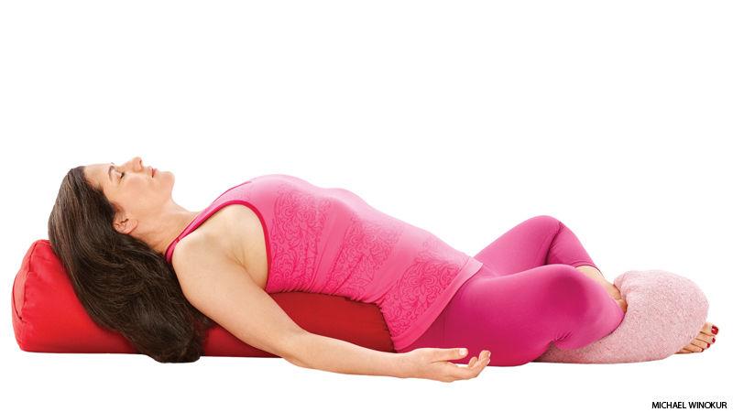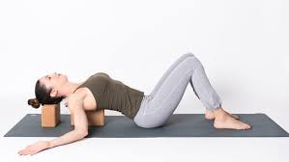

- Supine Lower Elevated
SELECTED PURPOSE:
- Elevation of lower body
- Opening/flow/stretch to all or some part of the front of the body.

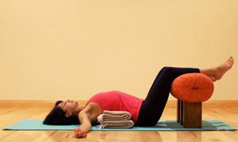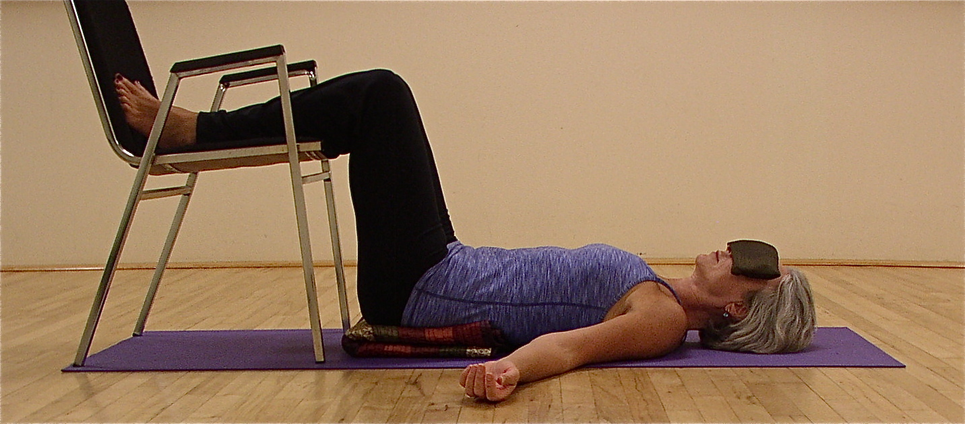

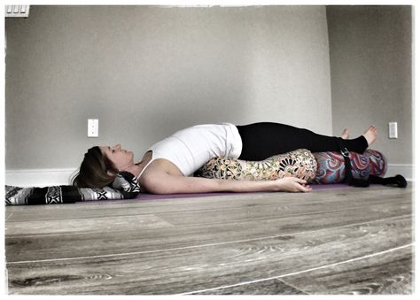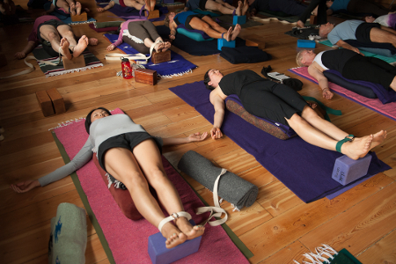

- Supported Forward Bend (Showing mostly spread leg)
SELECTED PURPOSE:
- To support forward bends for further relaxation in poses (able to hold longer)
- To enable forward bends if inhibited by some factor and unable to perform pose
- To bring focus to the back versus the backs of legs
- To bring focus to the legs (hamstrings) versus the back
- To compress the abdomen

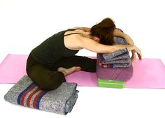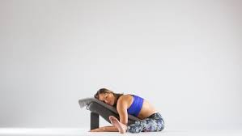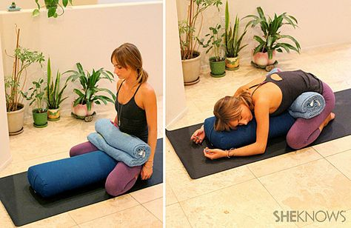

- Supported Twists
SELECTED PURPOSE:
- To elevate upper in twist if needed
- To lessen the depth of the twist (decrease range of motion RoM)
- To remove pressure from abdomen in twist
- To target specific areas of the body in twisting poses

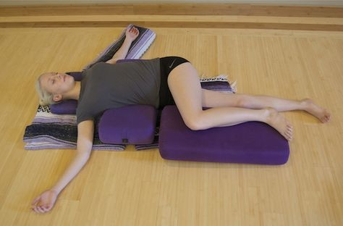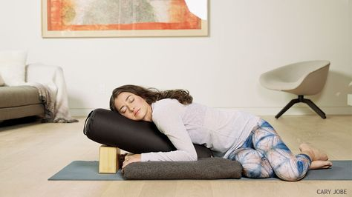
5. Supported Side Bend
SELECTED PURPOSE:
- To allows for further relaxation in pose (able to hold longer)
- To target specific areas of the side body in side bending
- To support head so focus can be on torso in side bending
- To support side torso so focus can be on neck in side bending

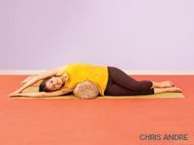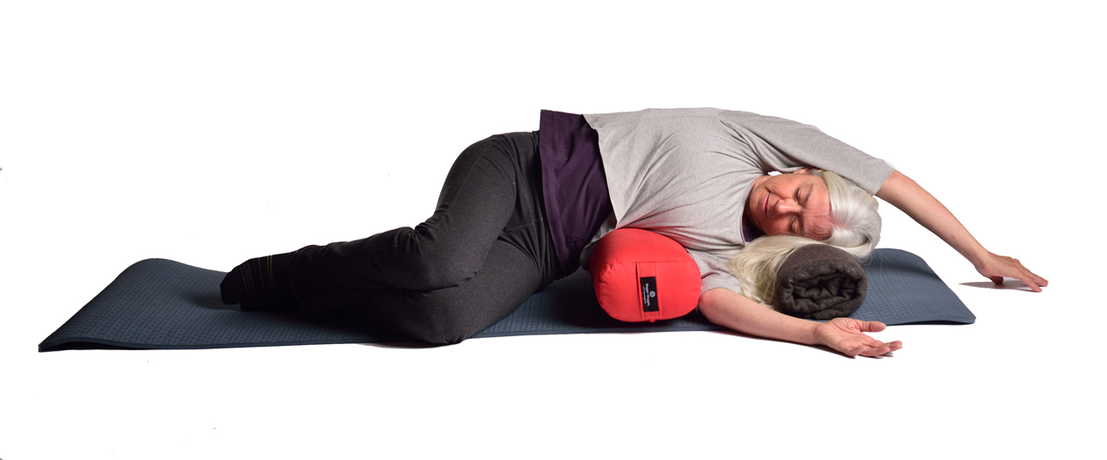

- Supported Shoulder Girdle Opening
SELECTED PURPOSE:
- To target specific muscles of the shoulder girdle area
- To support further relaxation (able to hold pose longer)

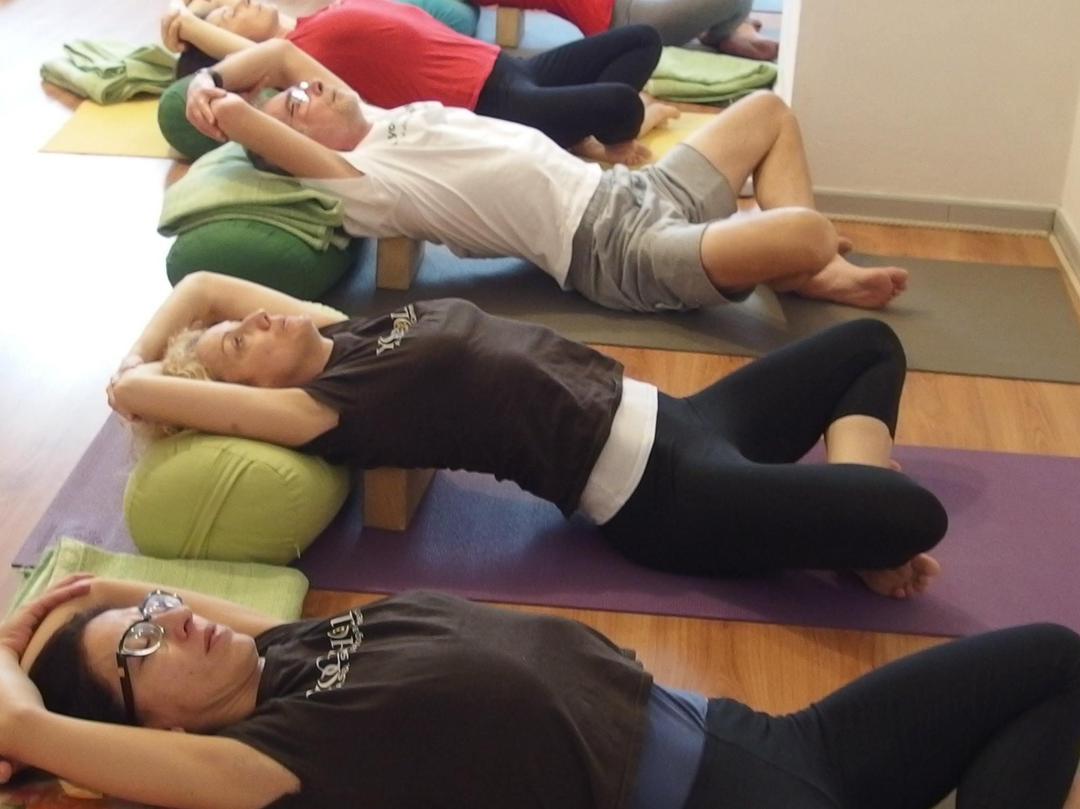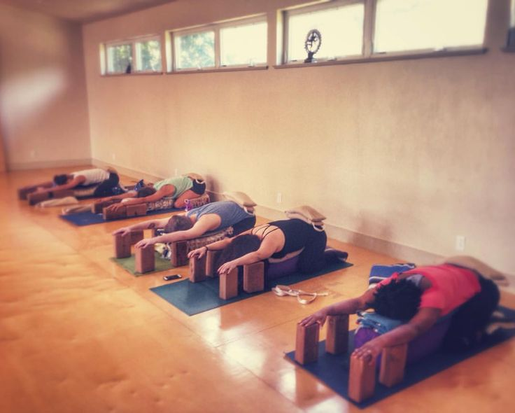

- Wall Work
SELECTED PURPOSE:
- To use the wall to enable various postures to be done with greater ease
- To enable the use of the limbs in deepening into poses
- To lessen the load of the legs
- To provide stabilization for balance and to give a sense of security for balance
- To support inversions and allow for greater relaxation (able to stay longer in pose)

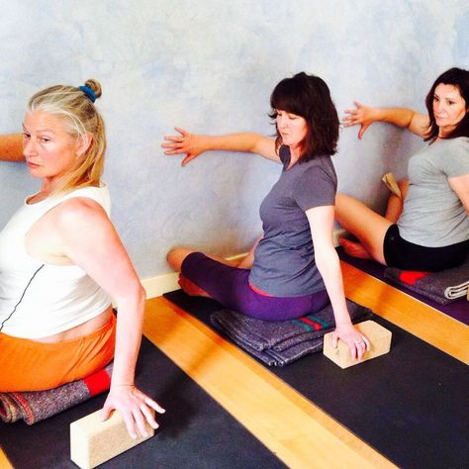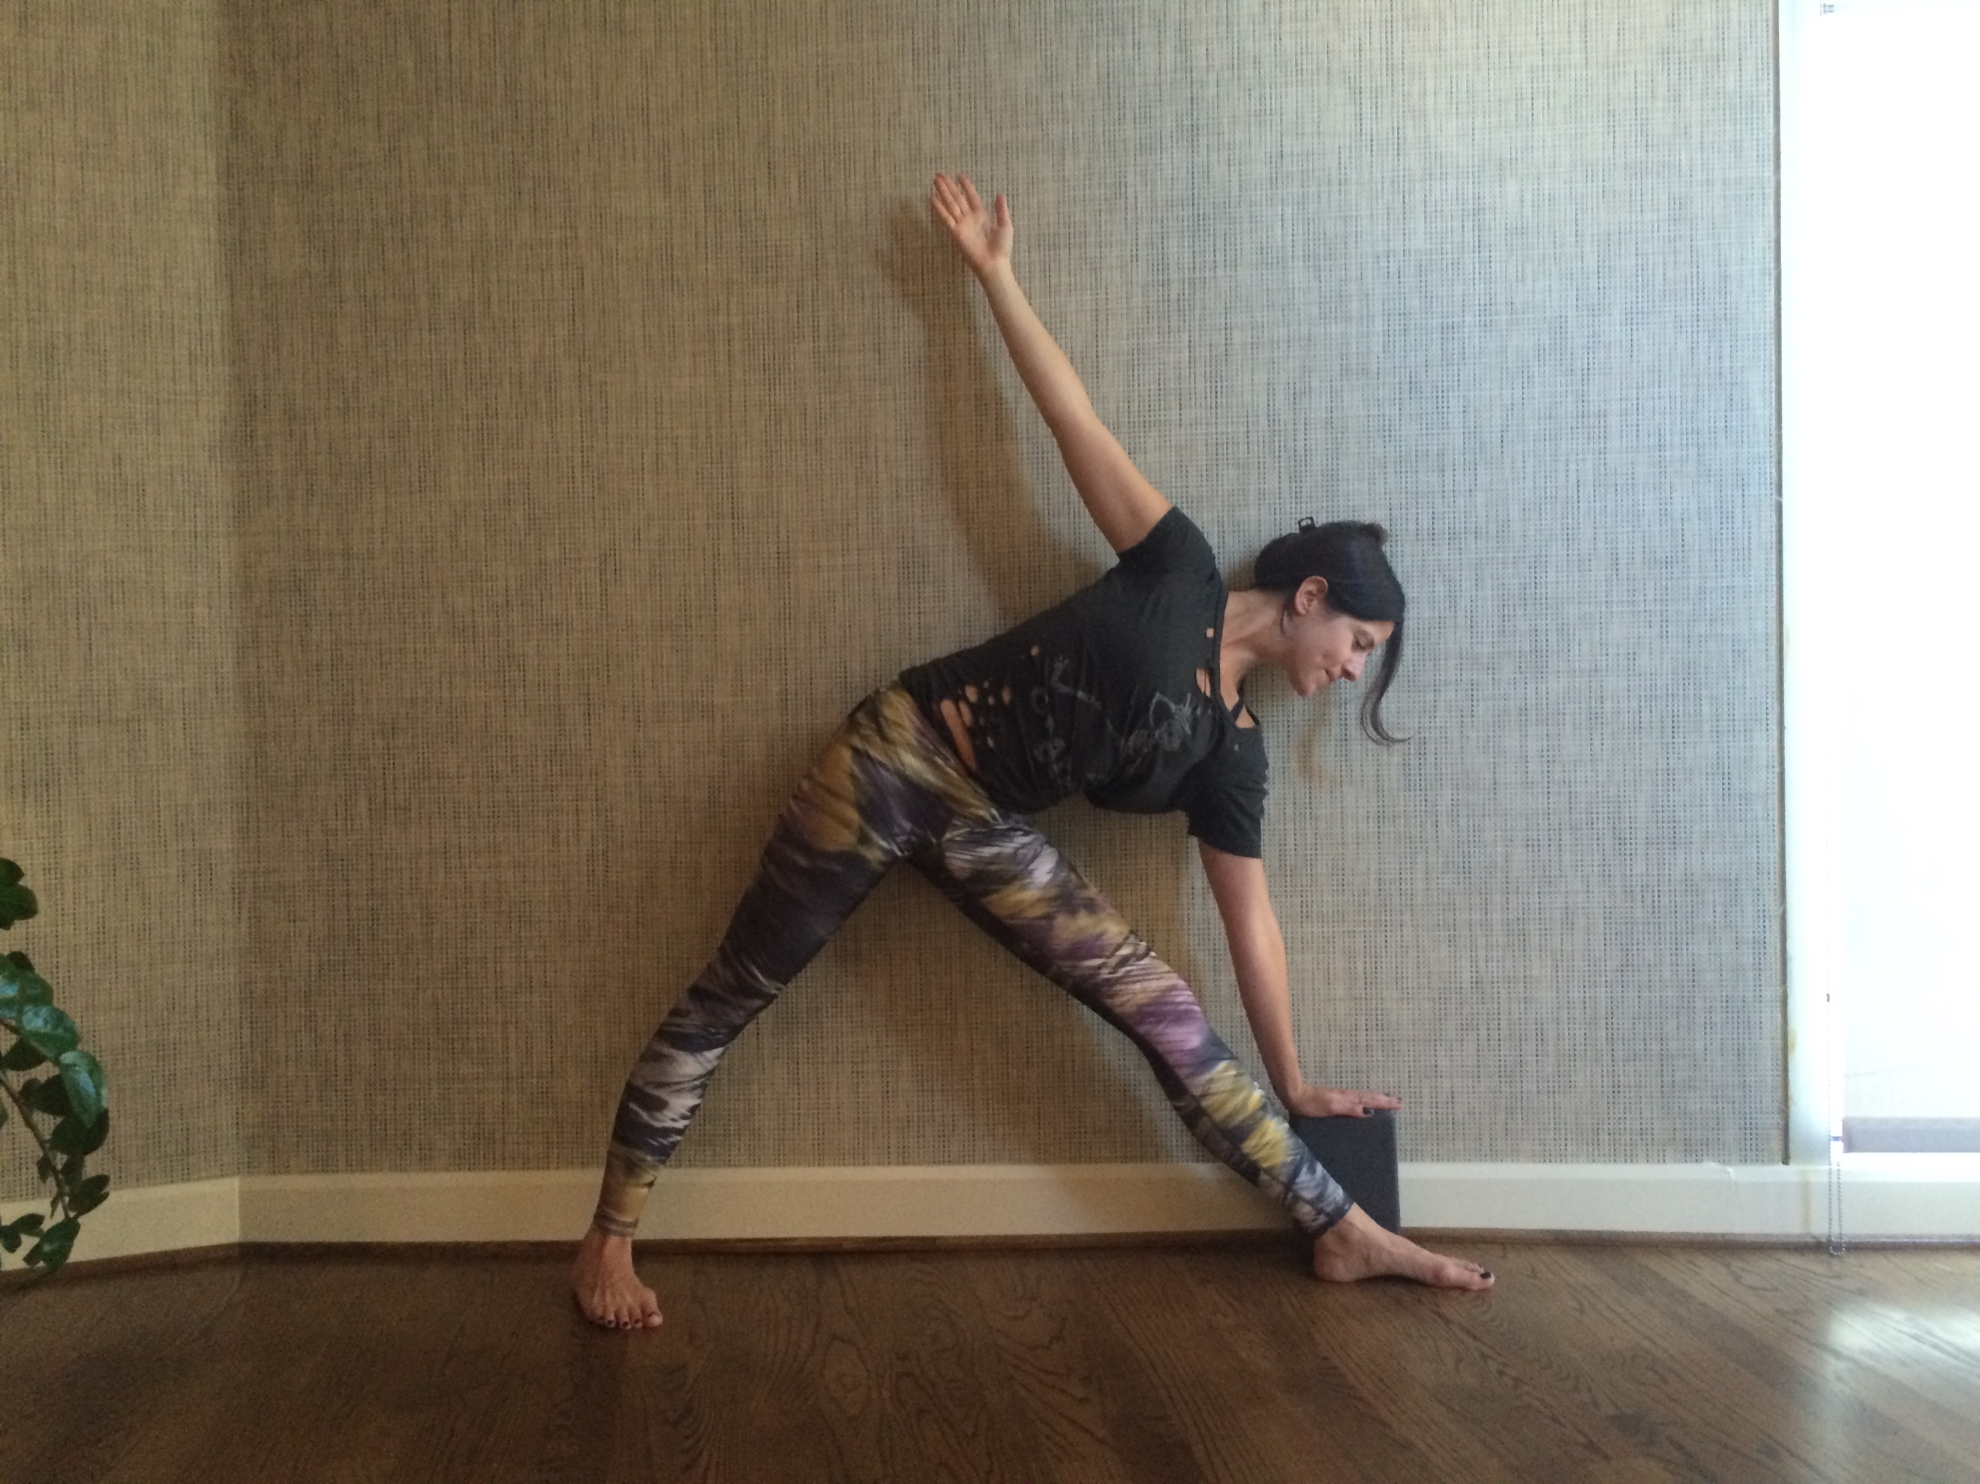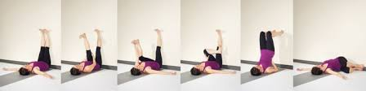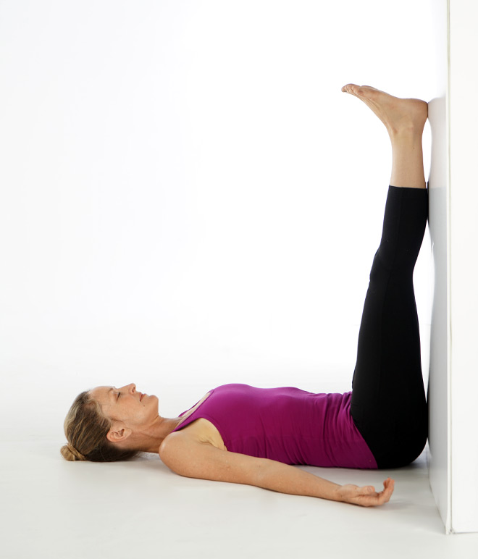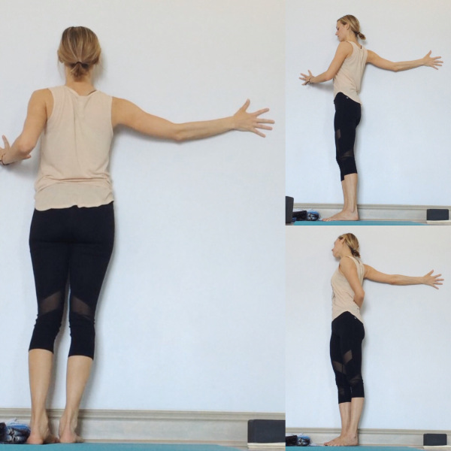

. . . and more . . . !

- Use of Compressional Weight
SELECTED PURPOSE:
- To encourage greater yielding in specific body areas
- To provide a sense of containment and stability
- To emphasize proprioceptive feedback in chosen body areas

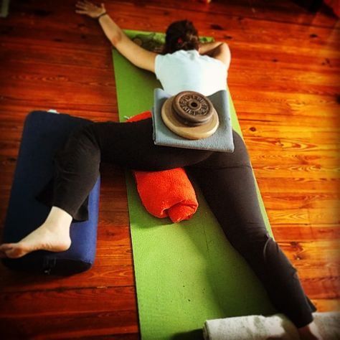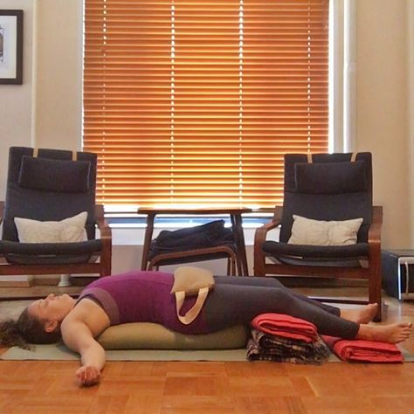
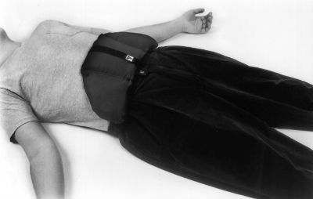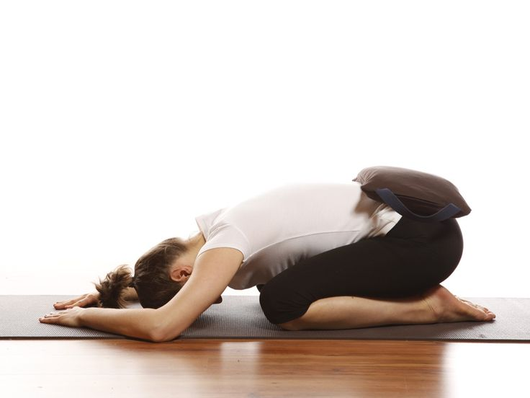

- Prone Poses
SELECTED PURPOSE:
- To support the various needs of the body in prone poses
- To elevate the feet
- To elevate and decompress the lumbar area
- To apply gentle pressure to the front of the pelvic and or abdominal area
- To open the chest (pectoralis area)
- To bring the neck to neutral extension (allow it to rest in symmetry) and relax tongue and jaw

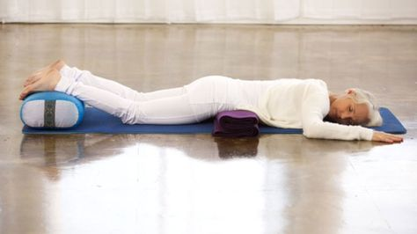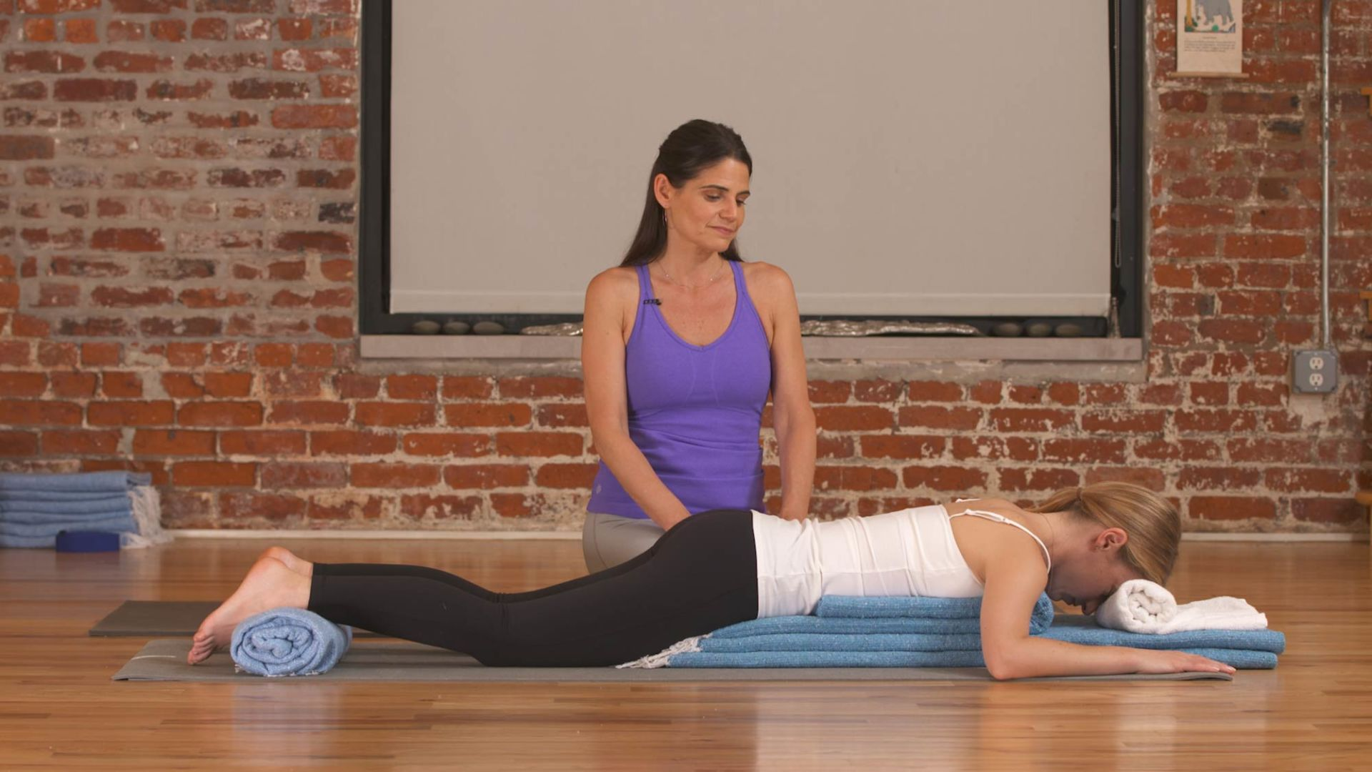

- Use of Hanging Weight
SELECTED PURPOSE:
- To allow muscles to elongate by gentle weighted traction
- To give various opportunity and support for muscles to yield into gravity

