The Role of Fascia in Spanda© Yoga Movement Therapy

Fascia is an important feature of our anatomy often overlooked in traditional presentations. Its importance in our work is related primarily to symptoms of pain and inhibition of mobility and its role in “stretching”, a main feature in yoga practice. Inhibited tissue mobility can have a cascading effect of further imbalance and subsequent injury throughout the body. Working with fascia can address some pain issues and can increase tissue cleansing as well as improve flexibility and mobility for greater ease, range of motion, and efficient movement patterning. We can also work with specific movement qualities and patterns in space to affect fascia. And we can train and re-educate movement to reduce pain in the future.

Everything in the entire body works synergistically. Fascia flows throughout the entire body and is a web-like unifier of forces throughout the body. Fascia can be divided into three main kinds based on its location in the body.

Superficial fascia is the lowermost layer of skin blending with the reticular or web-like dermis. It primarily determines the shape of the body. Fat can be laid down around it and it will stretch to accommodate it as it is “viscoelastic” (slippery and stretchy). It is just below skin and surrounds organs, glands, nerve and vascular tissues, and generally fills in otherwise unoccupied spaces in the body. Water and lymph “tubes” or passageways flow through it.

Visceral fascia suspends the organs within their cavities by wrapping them in layers of tissue. Each organ is covered in a double layer of fascia called the serous membrane. This membrane’s inner, or visceral layer and outer, or parietal layer secrete serous fluid that allows the membranes to slide over one another. Some names for these coverings may be familiar depending on their body area. For instance, in the brain, they are called meninges, in the heart they’re the pericardia, and in the lungs, they are the pleurae. The abdominal cavity’s covering is called the peritonea. Due to its role of suspending the organs, the fascia needs to maintain consistent tone. If lax, organ prolapse can result, and if too high tone (hypertonic), it can restrict organ mobility and motility (basic functional actions performed by healthy organs.)

Deep fascia surrounds individual muscles and divides muscle groups into fascial compartments. Deep fascia tends to have more elastin and so is considered to be slightly more mobile and expandable.

Living tissue is hydrated and dynamic. There are many layers of tissues with fluid between them, so to reduce pain and stiffness generally speaking, nutrition, hydration, sleep and motion are very important in keeping tissues mobile.

General Schemata of Skin to Muscle Layers including Fascia:
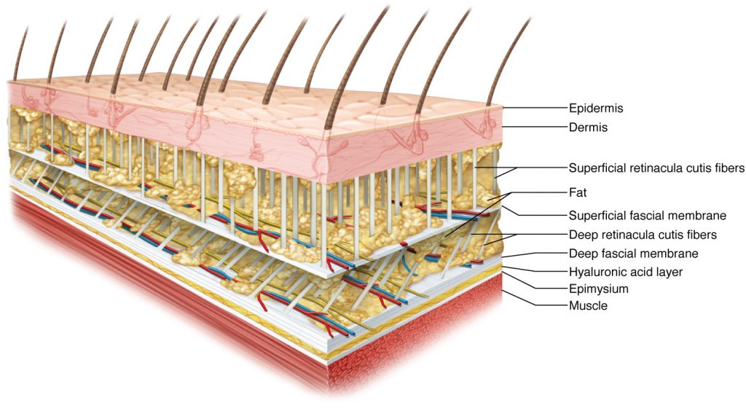
Skin
Fat
Superficial fascia
Fat
Deep fascia
Fluid Layer
Deep fascia
Muscle
Other deeper tissues

Breath initiated, medium tone vinyasa as in Spanda® Yoga is perhaps one of the best ways to mobilize fascia without creating any negative effects.
Components of Fascia

To get a better sense of why fascia has the stretching-yet-supportive, sticky-yet-sliding properties it does, let’s look at its components.

Fibroblasts - make and secret all CT fibers
Collagen Fibers – strong and abundant fibers providing the cross-linking tensile strength and
structure of fascia (picture spaghetti covered in olive oil sliding around.) These are what
lose plasticity as we age.
Elastin Fibers – rubber-like stretchy fibers that allow the tissue to regain its original size and
shape
Reticular Fibers – similar to collagen in that they form a netting or webbing that supports vessels with a
bit more “give’
Ground Substance – extracellular protein-based matrix that allows interstitial fluid to flow through it.
It acts like a fluid-soaking sponge and with inflammation it becomes “stickier” and is not as fully able to perform its fluid transport functions.

The ground substance acts like a sponge absorbing fluids that may hold extracellular toxins and other wastes. Moving with physical movement like repetitive vinyasa movement allows these fluids to enter the lymphatic drainage system (tubes that drain). With trauma, overtraining, toxicity in diet, medications, and for other reasons, this tissue can become overstressed and too viscous (sticky), preventing the flow of fluids into the lymphatic system. The result is edema (swelling) and overall lack of flow. This stagnation can be a breeding ground for other-than-our-own tissues! Yoga movements, shaking, bouncing, and recurrent movements on a dimensional or curved pathway can restore this flow by providing movement of energy and force into the system allowing the fluid matrix to thin and thus move the wastes that have accumulated (thixotrophy).

Fascia also transmit mechanical tension through the body as well as reduce some of the friction of muscular force. Fascial tissues are most often innervated by sensory nerve endings. Proprioceptive, nociceptive, and interoceptive functions of fascia has been considered valid by scientists. (Yogi’s are always glad to hear when science catches up! )

What Goes Wrong

Fascia can lose its inherent stiffness, becomes too stiff, and in either case decrease its shearing ability. And when fascial tissue fails to differentiate adjacent structures effectively due to trauma or other causes, inflammatory fasciitis or fibrosis (excess tissue) and adhesions may result. This happens often after surgery where the fascia has been cut through and healing includes scarring that traverses surrounding tissue structures preventing their “original” natural movement. Sedentary lifestyles, working in one position at a desk, driving for a living, fashion, physical trauma, and holding one emotionally-fostered body attitude can cause fascia to build up in areas that become adherent as well.

Inflammation and adherence can lead to a vicious cycle of impairment and pain. Here’s one ideation of such a inhibitory cycle.

Mechanical Connective Tissue Changes (from Chris Daprato, P.T.)

Inflammation or Trauma

Secondary Movement Extracellular Matrix Response
Dysfunction

Tensegrity Affected Collagen Cross-Linking

Ground Substance
Viscosity +

Working with Fascia

Techniques to affect fascia approach it in ways designed to change its length and density and also to make changes in the viscosity or “stickiness” of the fluid layers so tissues can more easily glide one against another.

Some ways of working with fascia are:
various types of yoga movements static yogasana
ball work foam rollers
propped targeted stretching cupping
Rolfing press and stretch techniques
scraping techniques (GuaSha) voodoo bands
myofascial decompression methods (traction) shaking and vibratory work
acupuncture trigger point therapy
myofascial accessing Shiatsu (acupressure) . . . and others.

An approach to working with “itis”, which basically means inflammation, with respect to fascia would be focused on either:
(a) reducing inflammation if a recent occurrence, or
(b) purposefully irritating or stirring up the tissues to reduce adhesions or bulking tissue scarring
if inflammation and/or pain has persisted for some time.
So the duration of the imbalance adhesions, poor use, or tissue trauma has relevance to approaching it.

Just as fascia acts as a supportive scaffold and provides fluid mobility having innate plasticity, it also acts as a connector. It connects multiple muscles (primarily) in functional action chains commonly called kinetic chains (movement initiated at one motor segment and flowing through several successive joints.) These organizations of activation link tissues - especially muscular - together and work synergistically to support smooth integrated movement. When an issue such a pain or limited range of movement arises, we can look beyond the immediate site to related areas along the involved kinetic chain.

Fascia connects area of the body specifically in relation to kinetic chains. We can look at injury and areas of pain and lessened mobility in terms of which lines of activation they exist within. We may ask, “What is the movement that involves this or these areas, and in which directions does the movement flow?” So rather than working with one muscle at a time, like in some western approaches, we can look at muscle action in a coordinated fashion. We can discern which muscles are involved along a line of activation. Then we can work with movement along, and in relation to, these lines or kinetic chains.

A Word on Stretching

In order to lengthen or change the resting length of fascial tissue (sometimes called creep by the way ) recent studies show force needs to be applied to the tissues for 2 minutes or longer. This is longer than it takes to override a stretch reflex of about 21-30 seconds. However, it has also been shown that tissues respond collectively and synergistically, so studying them one at a time, while interesting, may not yield clinical interventions as powerful as those used for millennia. Also awareness of state of alertness of the person in question, their level of tone, is highly relevant.

While with relaxation and slowed sustained breathing, muscle sarcomeres can each be elongated to encourage muscle fiber length, nervous system monitoring, and automatic activation along with fascial density, tone and restrictions, all make the idea of stretching muscles much more complex. Fascial changes along with how the brain perceives tightness and pain are as much at play as muscle relaxation. And at times, tissues on the opposite side of a joint may be adherent and unable to fold and move out of the way in response to joint mobilization, fascial plane gliding, and muscle lengthening.

Trigger Points

Deep and beneath superficial fascial layers there may be areas of muscles that are tight and sore - perhaps you have come across some of your own painful nodules in your upper back or gluteal muscles. These are areas of muscle contracture with a build-up of calcium, and so they’ll have more shortened sarcomeres, higher nervous activation, with low blood perfusion, oxygen and nutrients. With these small areas of spasm within the muscles, the fascia is being measured by neural receptors (spindles). Fascial tissues wrapping muscle fibers can also densify becoming viscous and thick as well! These have been called Trigger Points, by Janet Travell M.D.; they are hyper-sensitive nodules. They can be active, referring elsewhere, and latent, locally felt. They have a feedback loop of pain which can then become a loop of pain that worsens and subsequently inhibit related areas. So, we see that the site of pain is often not the cause of pain, secondary compensation happens, and also pain may be referred elsewhere.

Myofascial Lines (or Tracks)
Made popular by Thomas Myers, they are considered to be a thickening of fascia along a line of action in the body. These lines also were a focus of ancient Chinese therapies and Ida Rolf created a form of bodywork called Structural Integration, or Rolfing prior to Mr. Myers revelations. As a massage therapist he noted this thickening and discerned specific lines of structural integrity, movement and force.

According to his Anatomy Trains concept, there are twelve specific fascial lines throughout the body.
- SBL -Superficial Back Line
- SFL – Superficial Front Line
- LL – Lateral Line
- SL – Spiral Line
- SFAL – Superficial Front Arm Line
- DBAL – Deep Back Arm Line
- DFAL – Deep Front Arm Line
- SBAL – Superficial Back Arm Line
- BFL – Back Functional Line
- FFL – Front Functional Line
- IFL – Ipsilateral Functional Line
- DFL – Deep Front Line

It is interesting to note that a classical balanced yoga practice addresses them all.
Conclusion
External techniques applied with objects like scrapers, bands, balls and the like can be useful, as can propped asana when designed for specific targeted fascial areas and with proper tissue preparation and awareness of the practitioner’s tissue capacity so as to prevent injury.
Working with fascia is working with an entire human being at all levels. Fascia is important to yoga therapy as stretching is often central to asana and vinyasa practice. Muscle stretching has met with far less scientific research than muscle contraction. Fascia, primarily the domain of various bodyworkers, is a large part of what we attend to, move, sense, and work with in asana and vinyasa practice, specifically when resistance or pain is felt and identified in our practice. Positive and productive change, I believe involves awareness, breath, warm-up and flow of fluids, prana and mind. As well, hydration, oi lination, supportive dietary components and specific movement qualities in terms of temporal and spatial rhythms can be vital in the mobilization of the cycle of adhesion. Emotional pain and memories can be embedded in these patterns of tissue immobilization as well. Spanda MATM Myofascial Accessing techniques are extremely valuable in locating and gently working with these cellular memories.

