All information given in this questionnaire is strictly confidential.

Today’s Date: __________________

CURRENT INFORMATION

Full Name: ________________________________________________________ Date of Birth: ________________________

Address: ______________________________________________________________ Age: _____ Gender Identity: _________

City/State/Zip: __________________________________________________________ Phone: _____________________________

Email: _____________________________________________ Referred by/hear of us? ________________________________

Emergency Contact:_____________________________________________________ Phone: ____________________________

Your physician: _____________________________________________ Physician’s contact: __________________________

Occupation: _______________________________________ Employer: _______________________________________________

CONCERN(S)
What is the primary concern or goal for today? Have you had this in the past? If so, describe.
_________________________________________________________________________________________________________________
_________________________________________________________________________________________________________________

Please describe when the above began. What makes it better/worse? Its severity? Anything else…
_________________________________________________________________________________________________________________
_________________________________________________________________________________________________________________
_________________________________________________________________________________________________________________
Is it? (circle one) getting worse getting better coming and going staying the same.
Please list other current concern(s):
Complaint Since Cause (if known)
________________________________________________________________________________________________________________
________________________________________________________________________________________________________________
________________________________________________________________________________________________________________
________________________________________________________________________________________________________________

Do you have any specific body discomfort? If yes, please describe: _______________________________________________________________________________________________________________
_______________________________________________________________________________________________________________
_______________________________________________________________________________________________________________

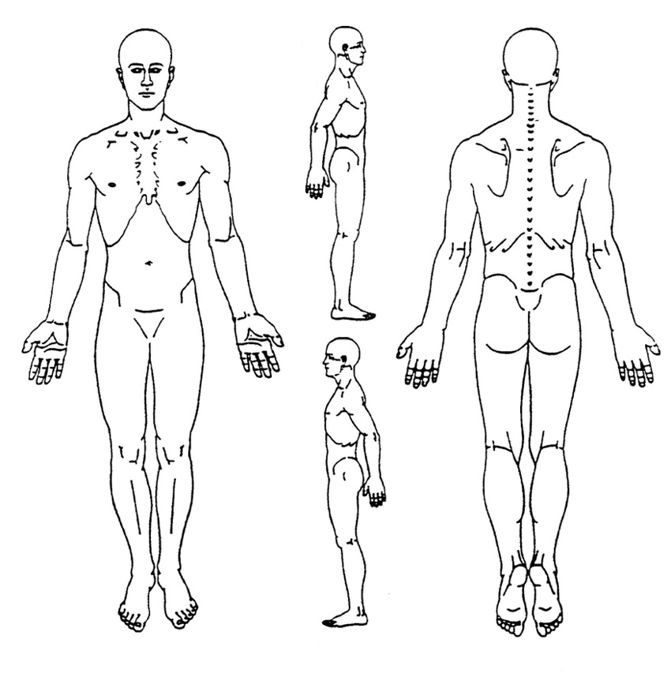

If relevant to your visit, please circle any problem areas in the drawing and if possible, write a word to indicate the type of sensation or sensations there, such as tight, burning, numb, sharp pain, etc.

Do you perform any repetitive movement in your work, sport, yoga practice, recreation, home care, or other activities?
________________________________________________________________________________________________________________
________________________________________________________________________________________________________________

Are you seeing healthcare or other service providers for this issue/condition? (acupuncturist, physical therapist, massage practitioner)? (Yes/No) If so what is the diagnosis and what treatment if any have your tried?

_______________________________________________________________________________________________________________
_______________________________________________________________________________________________________________
Have you made any observations about your body, energy, mental or emotional life, beliefs and life philosophy in relation to this concern that you would like to share?
____________________________________________________________________________________________________
____________________________________________________________________________________________________
____________________________________________________________________________________________________
____________________________________________________________________________________________________
In what way(s) do you think yoga movement therapy can be of help to you?
____________________________________________________________________________________________________
____________________________________________________________________________________________________

LIFESTYLE
How many hours do you work each week? __________ Do you like your work? ____________

Does your work stress or exhaust you? (Yes/No)

Do you generally get enough sleep? (Yes/No) Please describe: __________________________________________

Living Status: ____________________________________ Children: _________________________________________________
(single/married/partner/divorced/widowed)

Are you currently or have you recently gone through an unusually stressful life change or event?
(divorce, death in family, etc.)_______________________________________________________________________________
_________________________________________________________________________________________________________________
_________________________________________________________________________________________________________________

What kind of diet do you eat?
___ Typical American ___Vegetarian ___Vegan ___Other:

Do you smoke cigarettes, cigars, marijuana? (Yes/No) If yes, list:______________________________________

Do you drink alcohol? (Yes/No) If yes, how many drinks per week?___________________________________

Do you use recreational drugs? (Yes/No) If yes, what and how often? ________________________________
_______________________________________________________________________________________________________________

What do you do to exercise and how often? (Ex. Walk 30 min/5 days a wk.)
___________________________________________________________________________________________________
___________________________________________________________________________________________________

What current or past sport, movement, dance, performance or art experience do you have?
___________________________________________________________________________________________________
___________________________________________________________________________________________________

What is your experience with yoga, meditation or similar eastern or wholistic practices?
____________________________________________________________________________________________________
____________________________________________________________________________________________________
____________________________________________________________________________________________________

What are your biggest stressors? ______________________________________________________________

Do you sit for long hours at a workstation, computer, and/or driving?
____________________________________________________________________________________________________
____________________________________________________________________________________________________
____________________________________________________________________________________________________

List allergies to medicines, foods and environmental factors:
____________________________________________________________________________________________________
____________________________________________________________________________________________________
____________________________________________________________________________________________________

List prescriptions or over-the-counter medications taken regularly:
____________________________________________________________________________________________________
____________________________________________________________________________________________________
____________________________________________________________________________________________________

List vitamins, minerals, herbal preparations, tonics, supplements, flower essences, cell salts, homeopathic remedies or the like taken regularly:
____________________________________________________________________________________________________
____________________________________________________________________________________________________
____________________________________________________________________________________________________

What do you do for fun and/or to relax?
____________________________________________________________________________________________________
____________________________________________________________________________________________________

HISTORY
List major illnesses and hospitalizations (operations, injuries/accidents and their dates):
____________________________________________________________________________________________________
____________________________________________________________________________________________________
____________________________________________________________________________________________________
____________________________________________________________________________________________________
____________________________________________________________________________________________________

Have you ever been diagnosed with any of the following? If so, what year?

___Pneumonia ___Skin boils ___Obesity ___Rheumatic fever
___Tuberculosis ___Eczema ___Anemia ___Measles
___Asthma ___Psoriasis ___Blood transfusion ___Mumps
___Bronchitis ___Parasites ___Colitis ___Chicken pox
___Emphysema ___Jaundice ___Ulcer ___Polio
___High blood pressure ___Hepatitis ___Epilepsy/Seizure ___Whooping cough
___Low blood pressure ___Gallstones ___Mental breakdown ___Diphtheria
___Heart disease ___Kidney stones ___Arthritis __Lyme’s disease
___Drug reaction ___Bladder Infection ___Cancer ___Chronic Fatigue
___Migraine ___Hypoglycemia ___Syphilis ___fibromyalgia
___Hives ___Diabetes ___Gonorrhea ___Other:

Please list and briefly describe any conditions, medical or otherwise, that may prohibit or limit your practice of yoga stretches, movements, breathing, meditation, introspection, or relaxation:
____________________________________________________________________________________________________
____________________________________________________________________________________________________
____________________________________________________________________________________________________
List ailments of immediate family and indicate if deceased.
Mother: _______________________________________________________________________________________________
Father: ________________________________________________________________________________________________
Siblings: ______________________________________________________________________________________________
Is there anything else you would like me to know?
____________________________________________________________________________________________________
____________________________________________________________________________________________________
____________________________________________________________________________________________________

Practice and Student Practitioner Information, Consent and Waiver

SYMT Practice Information
Spanda® Yoga Movement Therapy is dedicated to the promotion of personal growth, wellbeing, and the prevention of chronic illness and injury whenever possible. Yoga is an ancient science that may benefit a person at every level of their being. Yoga Movement Therapy utilizes the time-tested techniques, principles and practices of yoga to support and facilitate natural mechanisms of healing, improved functionality, and increased self-awareness.

Student Practitioner Information
The yoga therapy session will be carried out by a student in the advanced level of the Spanda® Yoga Movement Therapist training. The student working with you is not a certified by the International Association of Yoga Therapists, the standard of professional yoga therapy worldwide, and is not yet qualified to offer yoga therapy outside of this practicum experience. However, the student is closely supervised by a yoga therapist who is certified by IAYT. Yoga therapist training, while including some teaching methods, is not a yoga teacher training but a professional level therapist training using the techniques and methods of yoga science and philosophy, many of which have scientific evidence supporting their efficacy. Your case may be discussed during supervision sessions with other trainees with the faculty supervisors while your right to privacy and anonymity will be ensured.

Practicum Consent
In consideration of receiving services rendered by ______________________________ I hereby declare the student has informed be that s/he is in the advanced phase of Spanda® Yoga Movement Therapy training and is receiving supervision of her/his practice sessions. I understand that supervision includes submission of written reports and dialogue with supervisors and other yoga therapist trainees. I have been informed of my right to request the use of my initials or a pseudonym in these interactions and written documents if I choose so. Also, the student has also informed me that s/he is not licensed as a healthcare provider under the laws in this state and is not practicing medicine. S/he will neither diagnose nor prescribe for any concern.

Waiver
I hereby release Spanda® Yoga Movement Therapy, and all other sponsoring agencies from responsibility for any injuries I may sustain as a result of participation in this work. I understand that I am encouraged to ask questions and discuss my progress with the therapist at all times, and that I have read the above, understand it, and engage in this practice of my own volition.

Date: _________________________________

Name: ______________________________________ Signature: __________________________

If under 21, Legal Guardian’s name: ____________________________________________
(Name) (Date)

Legal guardian’s signature: ______________________________________________

